MININET Simulation
INSTALLATION
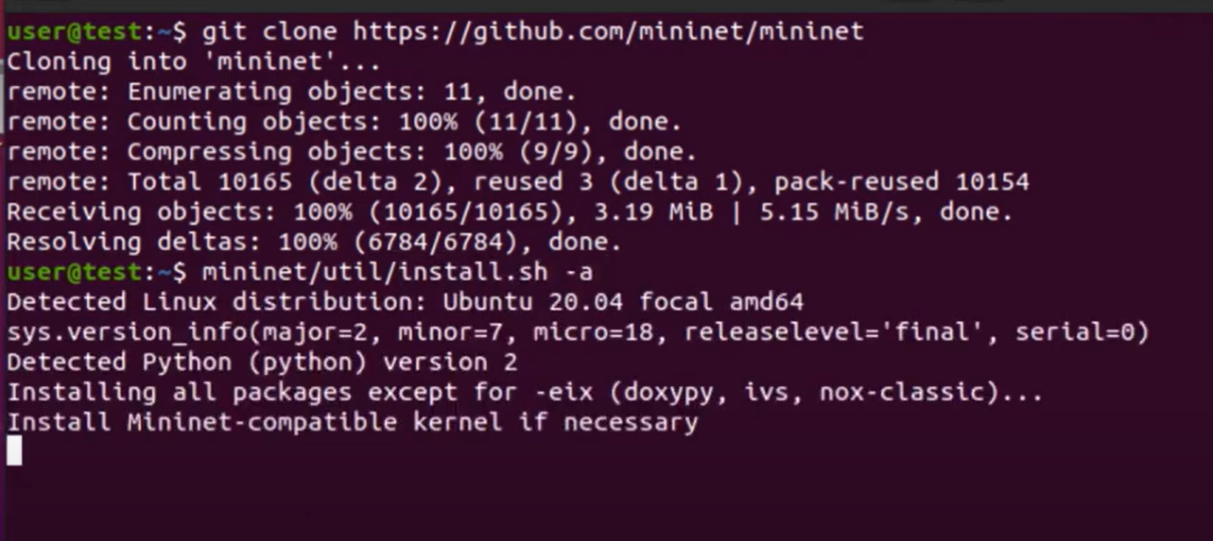
Login Details
Username: mininet
Password: mininet

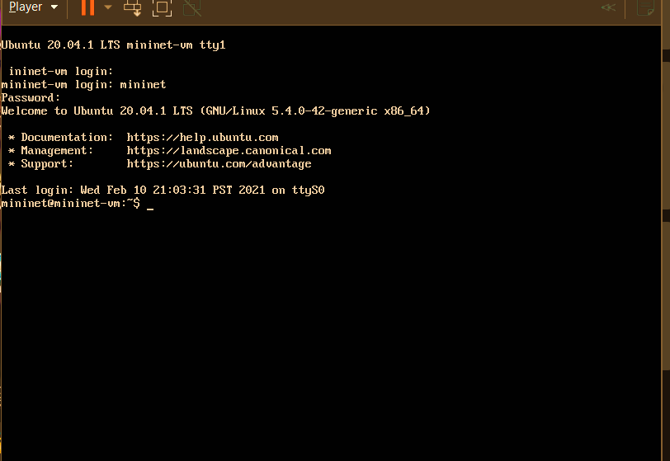

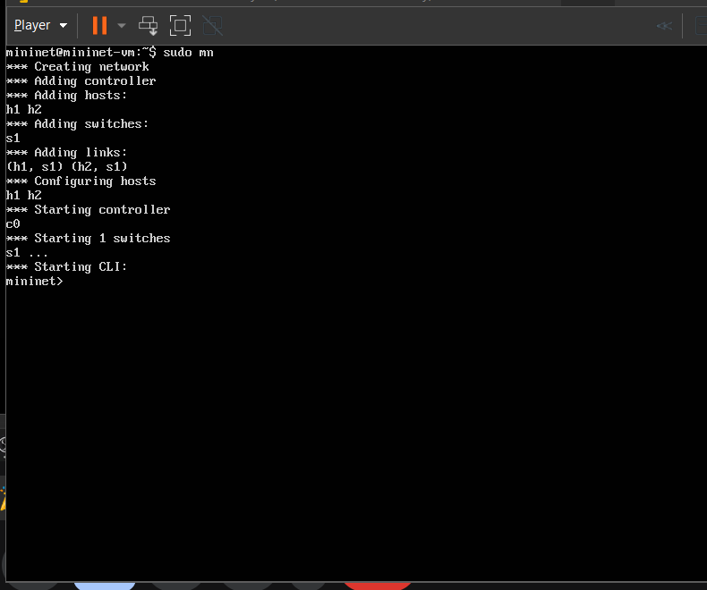
Opening mininet topology
Sudo mn

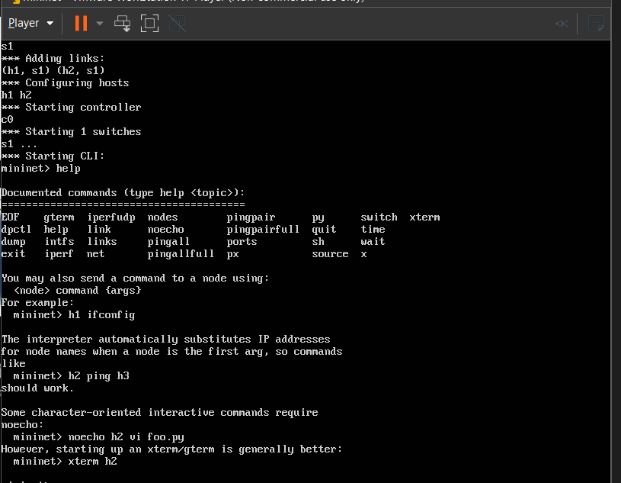
Command: help or ?
Shows the operations that we can perform
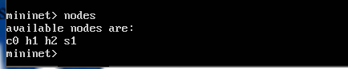
Command nodes
Shows the connected devices

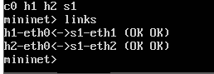
Command: links
Shows the connections between nodes, which node is connected to other and by which interface
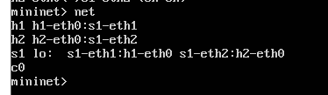
Command: net
Show the links between the nodes

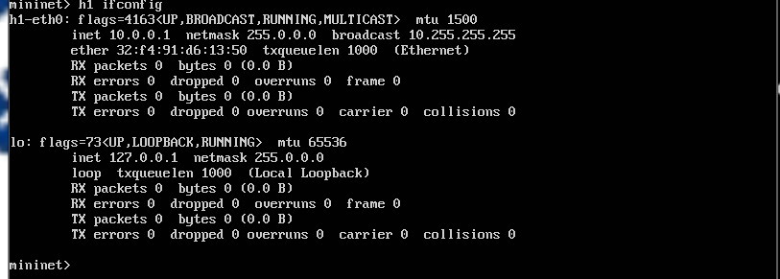
Command: h1 ifconfig
Show the description of h1 like ip address netmask connected ports and so on

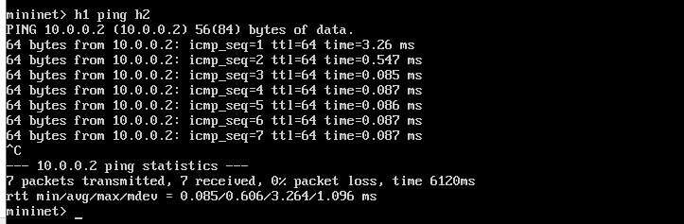
Command: h1 ping h2
Tests the connection of node h1 with node h2 and in this case it is successful connection.

